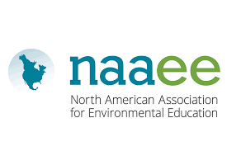
Executive Summary
Outdoor Learning as an Effective Strategy for Teaching during the Epidemic
Georgia schools entered uncharted territory when they reopened this year using a variety of models. There was no single standard approach: some districts brought students back to campus, some opened virtually, and many are following hybrid schedules that mix face-to-face and remote learning.

With community spread of the virus spiking again this fall, it remains important to follow guidelines from the Centers for Disease Control (CDC) and National Council for School Facilities (NCSF). Yet even with staggered scheduling and adaptive re-use of common areas in buildings, most schools lack sufficient space to accommodate even half the student body in terms of recommended physical distancing with students oriented in the same direction. These limitations, as well as the need for disinfection of shared surfaces and materials, has led some districts to exclude hands-on science labs and investigations. This trend is troubling since the Georgia Standards of Excellence were designed to actively engage students in science and engineering practices, as they attempt to make sense of core ideas.

Outdoor learning, both on school campuses and in the community, can help solve the physical distancing dilemma by providing additional instructional space. In addition, the CDC has determined that outdoor learning areas are less prone to spread of the virus than indoors because of improved air circulation; and outdoor surfaces require less sanitation. Learning outside also increases engagement; improves academic outcomes; and contributes to physical well-being and mental health, according to recent research.

Using the schoolyard to provide real-world context and to promote direct observation of phenomena are two outdoor instructional strategies that have long been valued in science classes, but can also benefit math, ELA, social studies, art, and other subjects. In contrast to the disproportionate challenges that remote learning poses for economically-disadvantaged children, outdoor learning promotes equity and inclusion by offering relevance, a common frame of reference, and increased interest and self-regulation.

Meanwhile, with school field trips off the table, the impacts of the epidemic and quarantine have left many non-profit environmental education providers with excess capacity, unused space, and untapped expertise. These underutilized resources could potentially provide space, technical assistance, and on-the-ground support for K-12 teachers. Partnerships between schools and community-based environmental education providers may offer benefits in these areas:
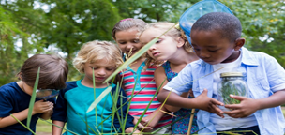
- Help Create Healthy Outdoor Learning Spaces at Schools
- Increase Capacity of School Faculty to Teach Outside
- Leverage Unused Space in the Community to Benefit Schools
- Expand Virtual Learning Resources, Platforms and Tours
- Provide Off-Campus, After-School Options for Working Parents
- Increase Relevance and Equity through Experiential Learning
- Outdoor Learning will Always be an Asset – even after Covid

The Environmental Education Alliance’s Council of Outdoor Learning (CoOL) has a CoOL Toolkit for Outdoor Learning with tips for creating and using outdoor learning spaces in the epidemic and beyond.
Executive Summary Pt 2: The Need for Outdoor Learning

Definitions

Environmental Education Provider An EE Provider is an individual or organization that engages students in activities that foster environmental literacy, environmental stewardship and / or environmental justice.

Outdoor Learning refers to educational activities that take place outdoors and provide an authentic, real-world context for learning.

Outdoor Classrooms are any space outside where students can observe phenomena and carry out learning activities, investigations, or projects in any subject. It does not require seating or facilities.

EEA (Environmental Education Alliance of Georgia) is a coalition of organizations and individuals that promotes environmental literacy and stewardship, encourages best practices, drives innovative initiatives, forges strategic partnerships, and is committed to the vision of a greener and healthier world for everyone.
Safely reopening schools requires resourcefulness, innovation, and modified procedures for everything from classroom configuration to schedules, transportation, health screenings, and meals. The good news is that community environmental education (ee) providers can help leverage school resources.

The challenges of bringing students back to school are daunting and range from ensuring physical well-being while community spread of the virus is still a threat; to overcoming the academic “covid slide”; forging new instructional strategies; and supporting families. School closures during the quarantine revealed inequities in education and spotlighted the vital role that schools play in providing educational technology, childcare, meals, and structure in addition to the usual learning activities. As schools reopen, returning students may be affected by the stress of the epidemic and trauma related to family illness or racial injustice. Many families are still facing difficulties returning to work, dealing with unemployment, or adapting to new school schedules and expectations. All of these situations place additional stress on educators too. As school districts look to the community for partnerships and support, local environmental education providers can be valuable assets to school administrators.

Outdoor areas, both on and off campus, offer space for learning, engagement, and health. Across all age groups, access to nature is associated with reduced stress, greater mental health, increased physical well-being and improved learning outcomes. During the epidemic, learning outdoors can improve physical distancing and offer options for labs and investigations that indoor classrooms no longer support. Outdoor learning also improves equity and inclusiveness by engaging all students in science and engineering practices to make sense of phenomena, instead of relying on previous exposure to contribute to academic success.
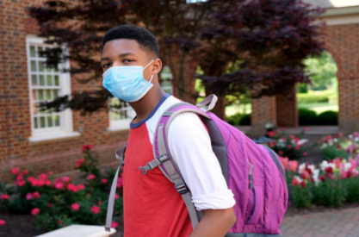
Image: Global News
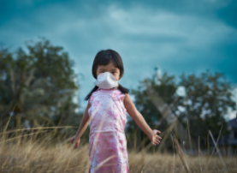
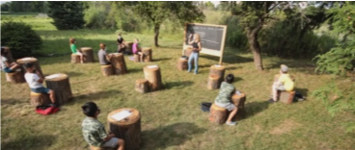
Local environmental education (ee) providers - including nature centers, parks, zoos, aquaria, water or solid waste departments, and non-profit organizations - are experienced in creating outdoor learning spaces, designing lessons backward from the standards, and managing students in hands-on investigations. Whether on campus or offsite, the expertise, capacity, and spaces that ee providers can offer are invaluable assets for schools districts and families. To find environmental education providers in your community, check www.EEinGeorgia.org or email KWood@eealliance.org. Read the full report here.

The Environmental Education Alliance’s Council of Outdoor Learning (CoOL) has a CoOL Toolkit for Outdoor Learning with tips for creating and using outdoor learning spaces in the epidemic and beyond.

