Articles about the Value of Outdoor Learning During the Epidemic
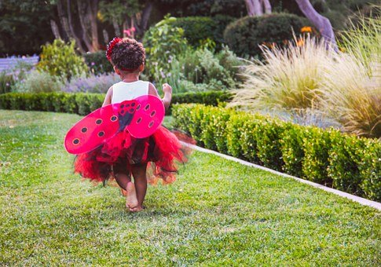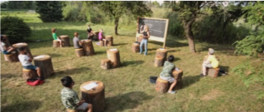

- Dr. Fauci: Schools Should be Outdoors as Much as Possible US News Aug 13, 2020
- What if Schools Considered Outdoor Learning as Plan A? EdSurge Oct, 2020
- Guide to Advocating for Outdoor Classrooms in the Corona-Virus Era NWF and NAAEE Oct 5, 2020
- Will the Outdoors Become the New Classroom of the Covid Era? Governing Aug 28, 2020
- You’re Less Likely to Catch Corona Virus Outdoors May 17, 2020
- How Green Schoolyards Can Help Make Schools Safer this Fall Finding Nature News Sep 4, 2020
- Teach Me Outside Nature Based Maine September 14, 2020
- Concern of the Future of Outdoor Learning Centers in Scotland September 4. 2020
- How Outdoor Learning Can Control Covid Transmission in Schools Green Schoolyards Sep 1, 2020
- Equity and Public Space August 20, 2020
- Outdoor Desks Replace Indoor Classes as a Way of Dealing with Covid-19 in Schools Aug 7, 2020
- What if We Radically Redesigned the New School Year? Chicago Unheard July 30, 2020
- The Push to Move Classrooms is Gaining Momentum New Yok Magazine Jul 29, 2020
- Let NYC Schools Use Outdoor Learning August 6, 2020 - webinar
- 10 Tips for Outdoor Learning from Scottish Schools August 10, 2020
- A California Collective Makes the Case for Outdoor Schooling PBS August 2, 2020
- Why Can’t We Just Have Class Outside? The Atlantic July 28, 2020
- How to Re-Open the Economy without Killing Teachers and Parents New York Times July 20, 2020
- Outdoor Learning a Key to Re-Opening Schools The Atlantic
- Outdoor Learning Model for Return to School After the Pandemic The Guardian May 10, 2020
- Schools Beat Earlier Plagues with Outdoor Learning New York Times, July 17, 2020
- Returning Safely to In-Person Instruction; What Educators Need to Know NEA Today July 13, 2020
- Why Outdoor Learning May Be the Key to Safely Re-Opening Schools Bioneers 2020
- How to Re-Open Schools – What Other Countries Can Teach Us New York Times July 11, 2020

