Executive Summary
Outdoor Learning as an Effective Strategy for Teaching during the Epidemic
Georgia schools entered uncharted territory when they reopened this year using a variety of models. There was no single standard approach: some districts brought students back to campus, some opened virtually, and many are following hybrid schedules that mix face-to-face and remote learning.

With community spread of the virus spiking again this fall, it remains important to follow guidelines from the Centers for Disease Control (CDC) and National Council for School Facilities (NCSF). Yet even with staggered scheduling and adaptive re-use of common areas in buildings, most schools lack sufficient space to accommodate even half the student body in terms of recommended physical distancing with students oriented in the same direction. These limitations, as well as the need for disinfection of shared surfaces and materials, has led some districts to exclude hands-on science labs and investigations. This trend is troubling since the Georgia Standards of Excellence were designed to actively engage students in science and engineering practices, as they attempt to make sense of core ideas.

Outdoor learning, both on school campuses and in the community, can help solve the physical distancing dilemma by providing additional instructional space. In addition, the CDC has determined that outdoor learning areas are less prone to spread of the virus than indoors because of improved air circulation; and outdoor surfaces require less sanitation. Learning outside also increases engagement; improves academic outcomes; and contributes to physical well-being and mental health, according to recent research.

Using the schoolyard to provide real-world context and to promote direct observation of phenomena are two outdoor instructional strategies that have long been valued in science classes, but can also benefit math, ELA, social studies, art, and other subjects. In contrast to the disproportionate challenges that remote learning poses for economically-disadvantaged children, outdoor learning promotes equity and inclusion by offering relevance, a common frame of reference, and increased interest and self-regulation.

Meanwhile, with school field trips off the table, the impacts of the epidemic and quarantine have left many non-profit environmental education providers with excess capacity, unused space, and untapped expertise. These underutilized resources could potentially provide space, technical assistance, and on-the-ground support for K-12 teachers. Partnerships between schools and community-based environmental education providers may offer benefits in these areas:
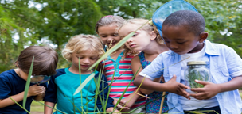
- Help Create Healthy Outdoor Learning Spaces at Schools
- Increase Capacity of School Faculty to Teach Outside
- Leverage Unused Space in the Community to Benefit Schools
- Expand Virtual Learning Resources, Platforms and Tours
- Provide Off-Campus, After-School Options for Working Parents
- Increase Relevance and Equity through Experiential Learning
- Outdoor Learning will Always be an Asset – even after Covid

The Environmental Education Alliance’s Council of Outdoor Learning (CoOL) has a CoOL Toolkit for Outdoor Learning with tips for creating and using outdoor learning spaces in the epidemic and beyond.
Executive Summary Pt 2: The Need for Outdoor Learning

Definitions

Environmental Education Provider An EE Provider is an individual or organization that engages students in activities that foster environmental literacy, environmental stewardship and / or environmental justice.

Outdoor Learning refers to educational activities that take place outdoors and provide an authentic, real-world context for learning.

Outdoor Classrooms are any space outside where students can observe phenomena and carry out learning activities, investigations, or projects in any subject. It does not require seating or facilities.

EEA (Environmental Education Alliance of Georgia) is a coalition of organizations and individuals that promotes environmental literacy and stewardship, encourages best practices, drives innovative initiatives, forges strategic partnerships, and is committed to the vision of a greener and healthier world for everyone.
Safely reopening schools requires resourcefulness, innovation, and modified procedures for everything from classroom configuration to schedules, transportation, health screenings, and meals. The good news is that community environmental education (ee) providers can help leverage school resources.

The challenges of bringing students back to school are daunting and range from ensuring physical well-being while community spread of the virus is still a threat; to overcoming the academic “covid slide”; forging new instructional strategies; and supporting families. School closures during the quarantine revealed inequities in education and spotlighted the vital role that schools play in providing educational technology, childcare, meals, and structure in addition to the usual learning activities. As schools reopen, returning students may be affected by the stress of the epidemic and trauma related to family illness or racial injustice. Many families are still facing difficulties returning to work, dealing with unemployment, or adapting to new school schedules and expectations. All of these situations place additional stress on educators too. As school districts look to the community for partnerships and support, local environmental education providers can be valuable assets to school administrators.

Outdoor areas, both on and off campus, offer space for learning, engagement, and health. Across all age groups, access to nature is associated with reduced stress, greater mental health, increased physical well-being and improved learning outcomes. During the epidemic, learning outdoors can improve physical distancing and offer options for labs and investigations that indoor classrooms no longer support. Outdoor learning also improves equity and inclusiveness by engaging all students in science and engineering practices to make sense of phenomena, instead of relying on previous exposure to contribute to academic success.
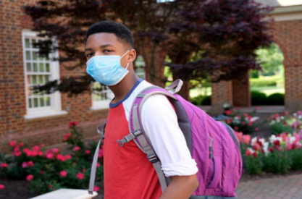
Image: Global News
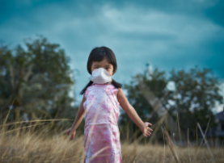
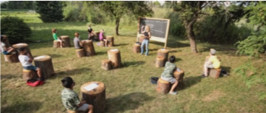
Local environmental education (ee) providers - including nature centers, parks, zoos, aquaria, water or solid waste departments, and non-profit organizations - are experienced in creating outdoor learning spaces, designing lessons backward from the standards, and managing students in hands-on investigations. Whether on campus or offsite, the expertise, capacity, and spaces that ee providers can offer are invaluable assets for schools districts and families. To find environmental education providers in your community, check www.EEinGeorgia.org or email KWood@eealliance.org. Read the full report here.

The Environmental Education Alliance’s Council of Outdoor Learning (CoOL) has a CoOL Toolkit for Outdoor Learning with tips for creating and using outdoor learning spaces in the epidemic and beyond.
Considerations for Implementing Outdoor Learning during the Pandemic
- Create Healthy Outdoor Learning Spaces at Schools
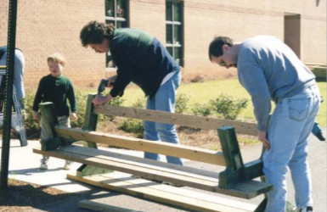
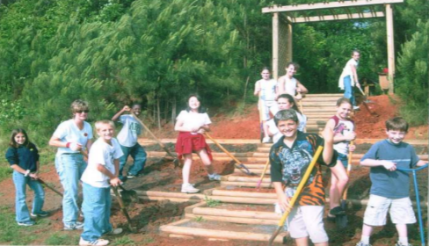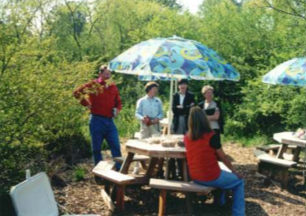
Guidelines from the National Council for School Facilities (NCSF) suggest that schools allow 44 square feet per student, which provides the CDC recommended 6 feet of distance between any two forward-facing students, in addition to space for a teacher to move about the room. Based on this guidance, NCSF estimates most schools will be able to operate safely at about 60% of total capacity.

To find additional space, most schools are repurposing specialized areas such as media centers, cafeterias, gyms, art and music rooms to create additional classrooms. In some cases, this reconfiguration may solve the problem of physical capacity inside the building. However, many schools lack sufficient space even after all of the common areas have been integrated into a plan for re-opening. Schoolyards are often-overlooked assets that can expand learning spaces for labs and investigations.

What Schools Should Consider
- When taking stock of usable space for physical distancing, school districts should remember to consider school grounds, including natural, grassy and paved surfaces that can be used for outdoor learning.
- Research suggests that risk of the spread of COVID-19 is reduced in outdoor settings with good air flow.
- Being outdoors makes it easier for students to maintain healthy distances from each other.
- Outdoor learning provides great opportunities for observing phenomena, engaging students in science an engineering practices, and deepening student engagement through sense-making in a real-world context.
- Science is not the only class suited for outdoor learning. Language arts, social studies, math, art and PE too!
- While the weather is not always conducive to outdoor learning, Georgia’s mild climate helps, and shade or rain shelters – including event tents - can extend the days when students can comfortably learn outside.
- Despite a common perception of students in “outdoor classrooms” being seated on rows of benches facing a lectern, neither amphitheaters, pavilions, nor permanent structures are needed to teach effectively outside.
  - Prioritize providing work surfaces to promote active investigations, rather than benches for seating.
  - Outdoor learning spaces can be inexpensive, versatile, and portable: not permanent and pricey
- Local environmental education (ee) providers are expert in creating outdoor learning spaces. They may be able to inventory campus assets and offer valuable planning assistance. Check www.EEinGeorgia.org
- Environmental Education Alliance has a Toolkit for Outdoor Learning with tips for outdoor learning spaces.

How EE Providers Can Help
- Some of the most effective “outdoor classrooms” take the form of school gardens, 5-gallon bucket “seats” with clipboard “desks”, weather stations mounted on pre-fabricated sections of wooden fencing, cable spools used as tabletops; or half picnic tables (flip-top benches) and tents. Local environmental education (ee) providers can often help with planning, sourcing of materials or kits, and technical assistance.
- Most districts have an approval process that leaves some improvements to the discretion of the principal while requiring others to be approved by the district. Pre-fabricated kits are easiest to assemble; do not require approval by an engineer; and reduce a school district’s liability, relative to custom-built improvements.
- Inexpensive pergolas, fabric shade screens, and open tents can extend outdoor learning “seasons.”
- Local businesses, Telephone Pioneers, Master Gardeners, Scouts, parents, and volunteers may be willing to contribute materials, offer discounts, or help assemble outdoor learning stations.

The Environmental Education Alliance’s Council of Outdoor Learning (CoOL) has a CoOL Toolkit for Outdoor Learning with tips for creating and using outdoor learning spaces in the epidemic and beyond.
- Build Teacher Capacity before Schoolyard Infrastructure
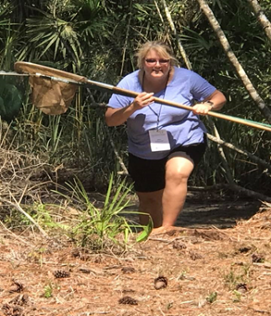
The reopening of schools requires teachers to adapt to yet another “new normal.” Depending on the district’s reopening model, teachers may need to physically reconfigure their classrooms, implement disinfection protocols between classes, create individual supply kits or lab set-ups if sharing is prohibited, convert hands-on activities to virtual assignments, and continue to create distance learning content, as well as work packets for students without internet-connected devices. So, the extent to which outdoor learning will seem like a welcome strategy to make learning more relevant, engaging, and safe depends on teacher familiarity with outdoor classroom management and instructional strategies.

Some K-12 teachers are prepared to take advantage of the opportunity to teach outside immediately, based on previous experience or professional learning. [Georgia is one of three states that has a nationally-accredited certification program: Advanced Training in Environmental Education in Georgia, or ATEEG, offered by the Environmental Education Alliance [EEA] and University of Georgia.] Teachers who have never taught outside before will benefit from professional learning and teaching resources available from EEA and local environmental education (ee) providers. It is always preferable to invest in teachers before facilities. A well-prepared teacher can lead an effective investigation outdoors with no special infrastructure, while the coolest outdoor learning space will sit unused if teachers feel unprepared.

In addition to professional learning and lesson resources, those who are new to teaching outside often appreciate help. Before the epidemic, “Earth Parent” volunteers could be recruited to assist teachers in managing students outdoors, helping set up field investigations, etc. now, when CDC guidelines discourage parents in the classroom, schools may want to turn to community ee providers for assistance.
What Schools Should Consider
- Provide professional learning and consult with teachers before designing and creating outdoor learning spaces.
- Consult local ee providers for help assessing the campus for possible outdoor learning spaces and recommendations about maximizing use
- Leverage the expertise of local environmental education (ee) providers to offer professional development and training for teachers
- CDC guidelines make it difficult to use parents as volunteers. But the guidelines allow partnering with experienced, local environmental ed providers for long-term assistance with outdoor learning, classroom management and instruction, etc.
- Call on community-based programs such as nature centers, science centers, and watershed education programs for expertise in designing, organizing and setting up outdoor learning stations
- Partner with ee providers to help design or implement programs aligned with curriculum standards
- Engage ee providers to assist classroom teachers and support outdoor learning.
- Check www.EEinGeorgia.org or email Environmental Education Alliance to find nearby ee providers.
- The Environmental Education Alliance has a Toolkit for Outdoor Learning with free teaching resources.

How EE Providers Can Help
- Many local ee providers are prepared to help schools design and create outdoor learning spaces.
- EE providers are typically trained to use the schoolyard and natural environments as a context for learning across the curriculum; have expertise in class management and engaging students in outdoor settings; and to address the physical health and safety of participants outdoors.
- Local ee providers may be available to help schools facilitate outdoor learning by mentoring teachers.
- Many ee providers offer teacher workshops and curriculum materials such as Project WET, Project Wild and Project Learning Tree. This training can be arranged on school campus, to include more staff.
- Many local ee providers can help schools design outdoor learning spaces to enhance learning (i.e. shade structures, work surfaces, pollinator gardens, bird feeders, learning stations, etc.)

- Leverage Spaces in the Community to Benefit Schools
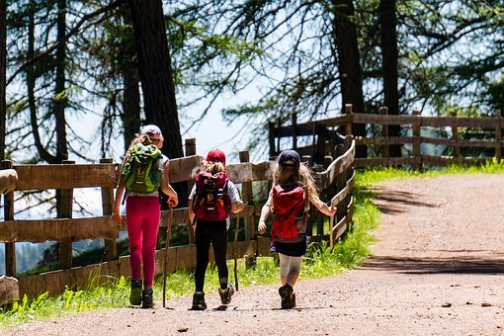
Community resources and parks may help schools leverage limited space where students can be safely distanced. Many nature centers and environmental education (ee) providers have been temporarily closed or are operating below capacity since schools are unable to go on field trips. Long-term partnerships with nearby underutilized facilities such as nature centers, parks, and outdoor schools, is one way to extend the school campus and increase capacity to maintain distance between students, while providing enriching educational experiences and equitable access to nature. It is also an opportunity to engage talented and experienced non-formal educators in supporting teachers.

What Schools Should Consider
- While field trips may not be possible during the epidemic, nature centers, parks, zoos, aquaria and other off-campus environmental education providers may have excess capacity now, including:
  - unused space that could be contracted by school districts as an extension of the campus;
  - available staff in safe settings, who may be able to host remote learners when parents have returned to work and cannot supervise learning at home;
  - locations for a hybrid or “shift” model, where students spend alternating days off campus (and transportation is provided by parents)
- Community-based environmental education programs are already adhering to the same health and safety standards as schools, as determined by state and local health departments, to accommodate safe distancing, frequent hand-washing, regular cleaning of high touch surfaces, and other guidelines to protect the health and safety of visitors.
- Partnering with local environmental ed providers who are already experienced in outdoor learning, can maximize distancing and minimize risk of spreading the virus
- Consider rotating appropriately-sized groups to partner facilities over the course of the school year for equitable access (with time between groups for adequate cleaning).
- Streamline planning for extended or multi-day off-campus learning experiences with local ee partners by providing tools such as annual and/or digital permission slips.
- Involving students in outdoor learning can provide relief from screen time and increase engagement
- Many environmental education (ee) providers also have indoor space available, internet access and can accommodate students whatever the weather
- EE providers often have capacity and expertise to deliver project-based learning experiences and in-depth STEM investigations that would be difficult to replicate in a school setting
- Check www.EEinGeorgia.org or email Environmental Education Alliance to find nearby ee providers.

How EE Providers Can Help
- Local ee providers may be willing to restrict public access to facilities during designated times while partnering with school districts to serve students
- Some local ee providers which partner with school districts to increase space for safely-distanced learning, may also be able to coordinate on transportation logistics so that students report to and leave from the off campus facility on assigned days
- EE providers can deliver standards-based learning activities and collaborate with schools to create new content, as needed

- Expand Virtual Learning Resources
Many school districts are employing strategies for reopening schools that involve continuation of virtual learning for some or all students. Many outdoor and environmental education (ee) providers have pivoted to provide content-rich virtual field trips and tours, webinars targeted to students, remote Ask an Environmental Expert sessions, or other digital content. These virtual resources can enliven the typical Zoom, Meet, or face to face classes; engage students more interactively than lecture and text-book driven learning, and provide relevant standards-based content for the classroom teacher.

What Schools Should Consider
- Ask local ee providers about virtual field trips and tours of your area, if actual f2f field trips are not practical. Remember that virtual learning has opened new windows of opportunity, outside your immediate area.
- Seek opportunities for students to explore new places and interact with environmental educators online
- Some environmental education (ee) providers are available for live sessions, to answer student questions.
- Environmental education providers may be able to offer asynchronous webinars or to live stream programs for schools, customized by grade level and standards, for less than the cost of face to face field trips.
- Nonformal educators may also be able to supplement learning opportunities for students outside of school time, providing de-facto after school programming for working parents.
- Check www.EEinGeorgia.org or email Environmental Education Alliance to find nearby ee providers.

How EE Providers Can Help
- Many ee providers are already creating resources in virtual mode, creating and distributing virtual field trips, programs and presentations.
- EE providers may also be able to accommodate “pods” of learners outside of school or after school.
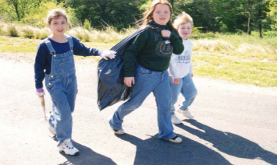
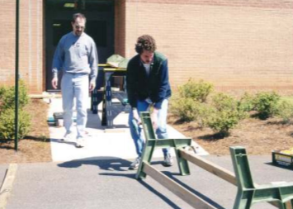
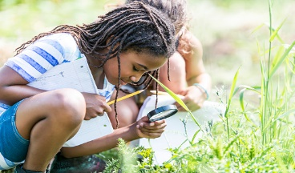
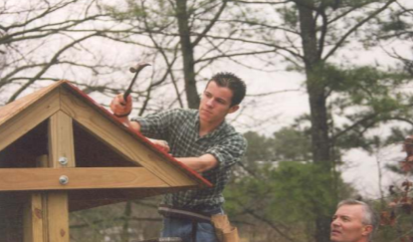
- EE providers may invest in resource-creation tools such as 360 degree cameras; virtual tour creator software, and other apps that make it easy to present virtual field trips or to film on-demand tours that enable students to explore and investigate.

- Create Options for Working Parents
As schools modify schedules and parents return to work (or attempt to increase productivity while working from home) families of students with partial or full-time virtual learning will continue to face childcare challenges. EE providers may be able to offer in-person supervision of small “pods” of students who follow teacher-directed online learning; provide after-school care; or 5th day enrichment programming for school districts that pivot to a four-day week to accommodate the increased responsibilities and preparation time needed by K-12 teachers.

What Schools Should Consider
- Developing relationships with community-based environmental education partners can contribute to student success by creating support networks for families.
- Check www.EEinGeorgia.org or email Environmental Education Alliance to find nearby ee providers.

How EE Providers Can Help
- EE providers may have excess capacity (due to their facilities being closed or in limited use) and so be able to provide programs and support for families during and after the school day.
- Increase Equity & Cultural Relevance through Outdoor Learning
The downsides to virtual learning fall disproportionately on families of “essential workers” who cannot telework, children of color, and low-income or rural communities. In addition to lack of technology or reliable internet, these children are more likely to have responsibilities – including work or taking care of siblings – that limit participation in remote classes. Black and Hispanic children are most likely to be hospitalized by covid-19 and experience trauma related to family illness. Remote learning can challenge anyone, but many special needs children struggle with online classes. Outdoor learning – in the backyard or in the schoolyard - can provide real-world relevance, increase engagement, and contribute to students’ academic success.
What Schools Should Consider
- Outdoor learning provides opportunities for students who struggle with virtual learning to be more successful academically by offering an authentic, real-world context for learning.
- Outdoor learning can make all students’ experiences relevant by emphasizing use of science and engineering practices to make sense of phenomenon, rather than prior knowledge or exposure.

How EE Providers Can Help
- EE providers can help schools create opportunities for authentic problem-solving, data collection, field investigations, and real world science; as well as effective outdoor learning in other subjects.
- Outdoor learning presents fewer health risks because of better air circulation and distancing.

Conclusions
Schools face enormous challenges in the 2020-2021 school year. The good news is that community partners can provide support, leverage resources, and reduce risks of spreading covid-19. Nature centers and other ee providers can collaborate with schools to re-imagine learning and bring to the table teaching expertise, excess capacity, physical space, and effective outdoor education models that provide safe and effective learning during the epidemic. In addition, outdoor learning reduces screen time and increases engagement.

Articles
  - Dr. Fauci: Schools Should be Outdoors As Much As Possible US News Aug 13, 2020
  - What if Schools Considered Outdoor Learning as Plan A? EdSurge Oct, 2020
  - Guide to Advocating for Outdoor Classrooms in the Corona-Virus Era NWF and NAAEE Oct 5, 2020
  - Will The Outdoors Become the New Classroom of the Covid Era? Governing Aug 28, 2020
  - You’re Less Likely to Catch Corona Virus Outdoors May 17, 2020
  - How Green Schoolyards Can Help Make Schools Safer this Fall Finding Nature News Sep 4, 2020
  - Teach Me Outside Nature Based Maine September 14, 2020
  - Concern of the Future of Outdoor Learning Centers in Scotland September 4. 2020
  - How Outdoor Learning Can Control Covid Transmission in Schools Green Schoolyards Sep 1, 2020
  - Equity and Public Space August 20, 2020
  - Outdoor Desks Replace Indoor Classes as a Way of Dealing with Covid-19 in Schools Aug 7, 2020
  - What if We Radically Redesigned the New School Year? Chicago Unheard July 30, 2020
  - The Push to Move Classrooms is Gaining Momentum New Yok Magazine Jul 29, 2020
  - Let NYC Schools Use Outdoor Learning August 6, 2020 - webinar
  - 10 Tips for Outdoor Learning from Scottish Schools August 10, 2020
  - A California Collective Makes the Case for Outdoor Schooling PBS August 2, 2020
  - Why Can’t We Just Have Class Outside? The Atlantic July 28, 2020
  - How to Re-Open the Economy without Killing Teachers and Parents New York Times July 20, 2020
  - Outdoor Learning a Key to Re-Opening Schools The Atlantic
  - Outdoor Learning Model for Return to School After the Pandemic The Guardian May 10, 2020
  - Schools Beat Earlier Plagues with Outdoor Learning New York Times, July 17, 2020
  - Returning Safely to In-Person Instruction; What Educators Need to Know NEA Today July 13, 2020
  - Why Outdoor Learning May Be the Key to Safely Re-Opening Schools Bioneers 2020
  - How to Re-Open Schools – What Other Countries can Teach Us New York Times July 11, 2020

The Environmental Education Alliance’s Council of Outdoor Learning (CoOL) has a CoOL Toolkit for Outdoor Learning with tips for creating and using outdoor learning spaces during the epidemic and beyond.

